APPENDIX B

PROJECT GANTT CHART
EvalSense: A Machine Learning-Based Sentiment Analysis System for Faculty Evaluation
This phase-based schedule summarizes the main work needed to design, build, and evaluate EvalSense. The manuscript provided for reference does not specify calendar dates; phase labels are used here until the team confirms the actual schedule.
Legend: ● Active phase
Project activity | Phase 1 | Phase 2 | Phase 3 | Phase 4 | Phase 5 | Phase 6
Requirements and literature review | ● | ●
System and database design |  | ● | ●
Data preparation and model development |  | ● | ● | ●
Web application implementation |  |  | ● | ● | ●
System integration and testing |  |  |  | ● | ●
User evaluation and analysis |  |  |  |  | ● | ●
Revision, documentation, and final submission |  |  |  |  | ● | ●
Figure B.1. Phase-based project schedule for the development of EvalSense. Replace the phase labels with the approved calendar months or weeks before final submission.

APPENDIX C

RELEVANT SOURCE CODE
The following excerpts are taken from the EvalSense source code. They illustrate the text preprocessing, sentiment classification, and evaluation processing used by the system.
Figure C.1. Text normalization and negation-aware preprocessing (ml/preprocess.py)
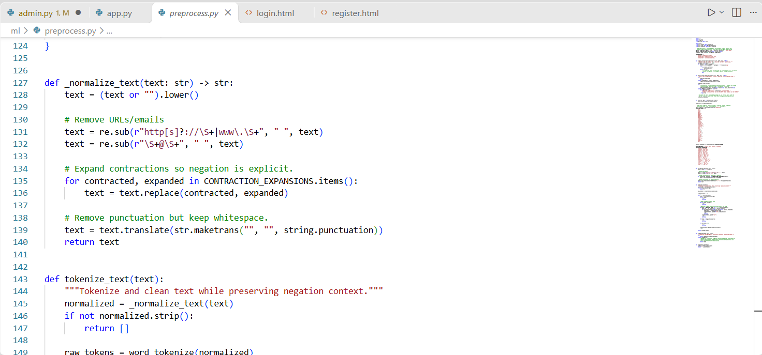
Figure C.2. Sentiment prediction using the trained classifier and vectorizer (ml/predict.py)
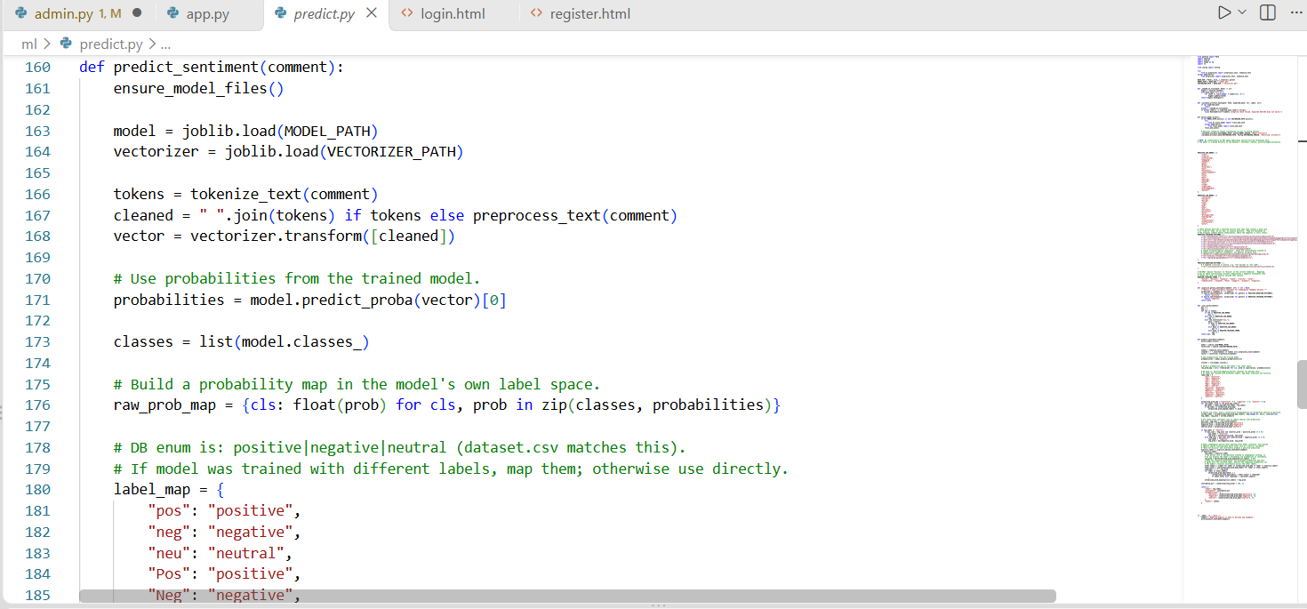

Figure C.3. Evaluation submission workflow (services/evaluation_service.py)
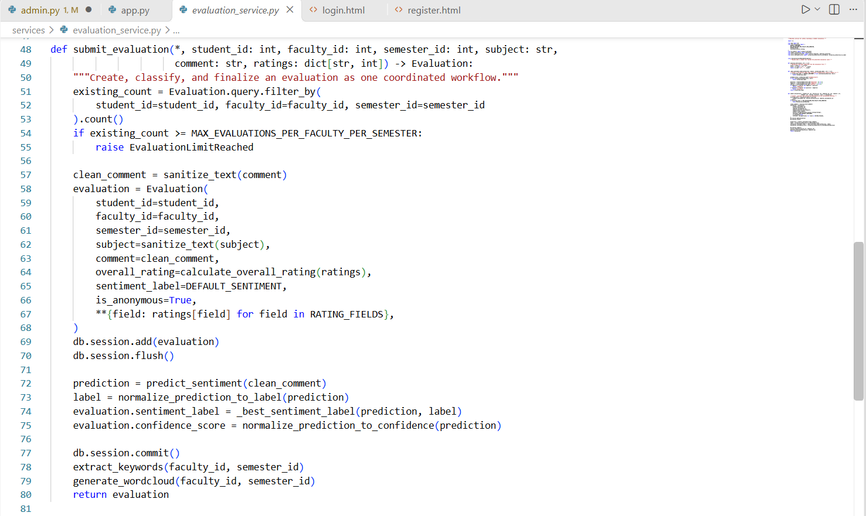
Figure C.4. Overall rating validation and calculation (core/evaluation.py)

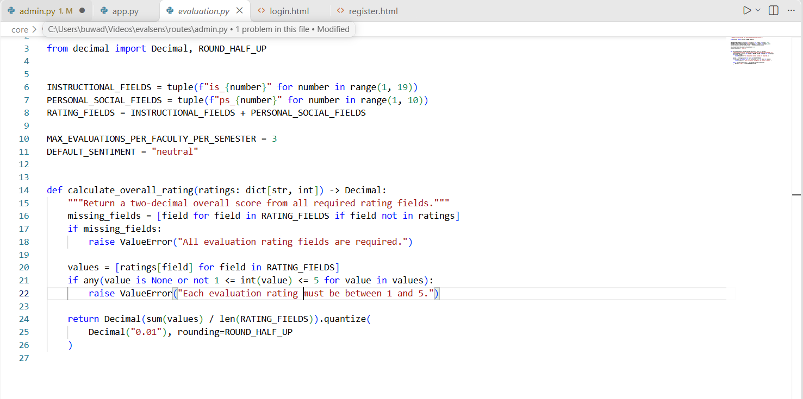

APPENDIX D
Installation Guide
This guide describes a local development or demonstration setup based on the project README. The application uses Python and MySQL.
- System Requirements
Python 3.10 or later, pip, MySQL Server, and internet access for package and NLTK downloads. Git is needed only when cloning the project.
- Open the project
Open a terminal in the project folder. When cloning from the team repository, replace the sample address with the repository URL.
git clone https://github.com/pakdottiki-cell/evalsens.git
cd evalsense

Create and activate a virtual environment
python -m venv venv

# Windows PowerShell
.\venv\Scripts\Activate.ps1

# macOS / Linux
source venv/bin/activate

Install dependencies
python -m pip install --upgrade pip
pip install -r requirements.txt

Configure the database
Start MySQL, create the database, then load the schema from the project root:
mysql -u root -p -e "CREATE DATABASE evalsense_db;"
mysql -u root -p evalsense_db < database/schema.sql

Create a .env file in the project root and replace the example database credentials with the values for your MySQL account. Generate a unique secret key and keep .env out of source control.
SECRET_KEY=<random-secret-at-least-32-characters>
MYSQL_USER=root
MYSQL_PASSWORD=<your-mysql-password>
MYSQL_HOST=localhost
MYSQL_PORT=3306
MYSQL_DB=evalsense_db
DATABASE_URL=mysql+mysqlconnector://root:<your-mysql-password>@localhost:3306/evalsense_db
Generate a random secret key with:
python -c "import secrets; print(secrets.token_urlsafe(48))"

Download NLTK data
Run these commands in a Python shell while the project environment is active:
import nltk
nltk.download("punkt")
nltk.download("punkt_tab")
nltk.download("stopwords")
nltk.download("wordnet")
nltk.download("omw-1.4")

Train the sentiment model
Train the classifier and create the model and vectorizer artifacts:
python ml/train_model.py
This creates ml/model.pkl and ml/vectorizer.pkl.

Create an administrator account
Run the bootstrap script and follow its prompts to set an administrator username and password:
python bootstrap_admin.py

Run the application
python app.py
Open the local application in a browser:
http://127.0.0.1:5000

Optional demo data
For local demonstration only, sample records can be loaded with:
mysql -u root -p evalsense_db < database/seed.sql
The seed file contains demo accounts and data. Do not load it into a production database.

Common setup checks
If MySQL connection fails, check that the server is running and the .env database settings match it. If packages are missing, activate the virtual environment and rerun pip install -r requirements.txt. If model files are missing, run python ml/train_model.py from the project root. If the SECRET_KEY check fails, set a newly generated secret in .env and restart the application.

APPENDIX E

USER GUIDE
This guide explains the main tasks available to students and administrators in EvalSense. The screens and menu names below follow the current application.

E.1 Accessing the system

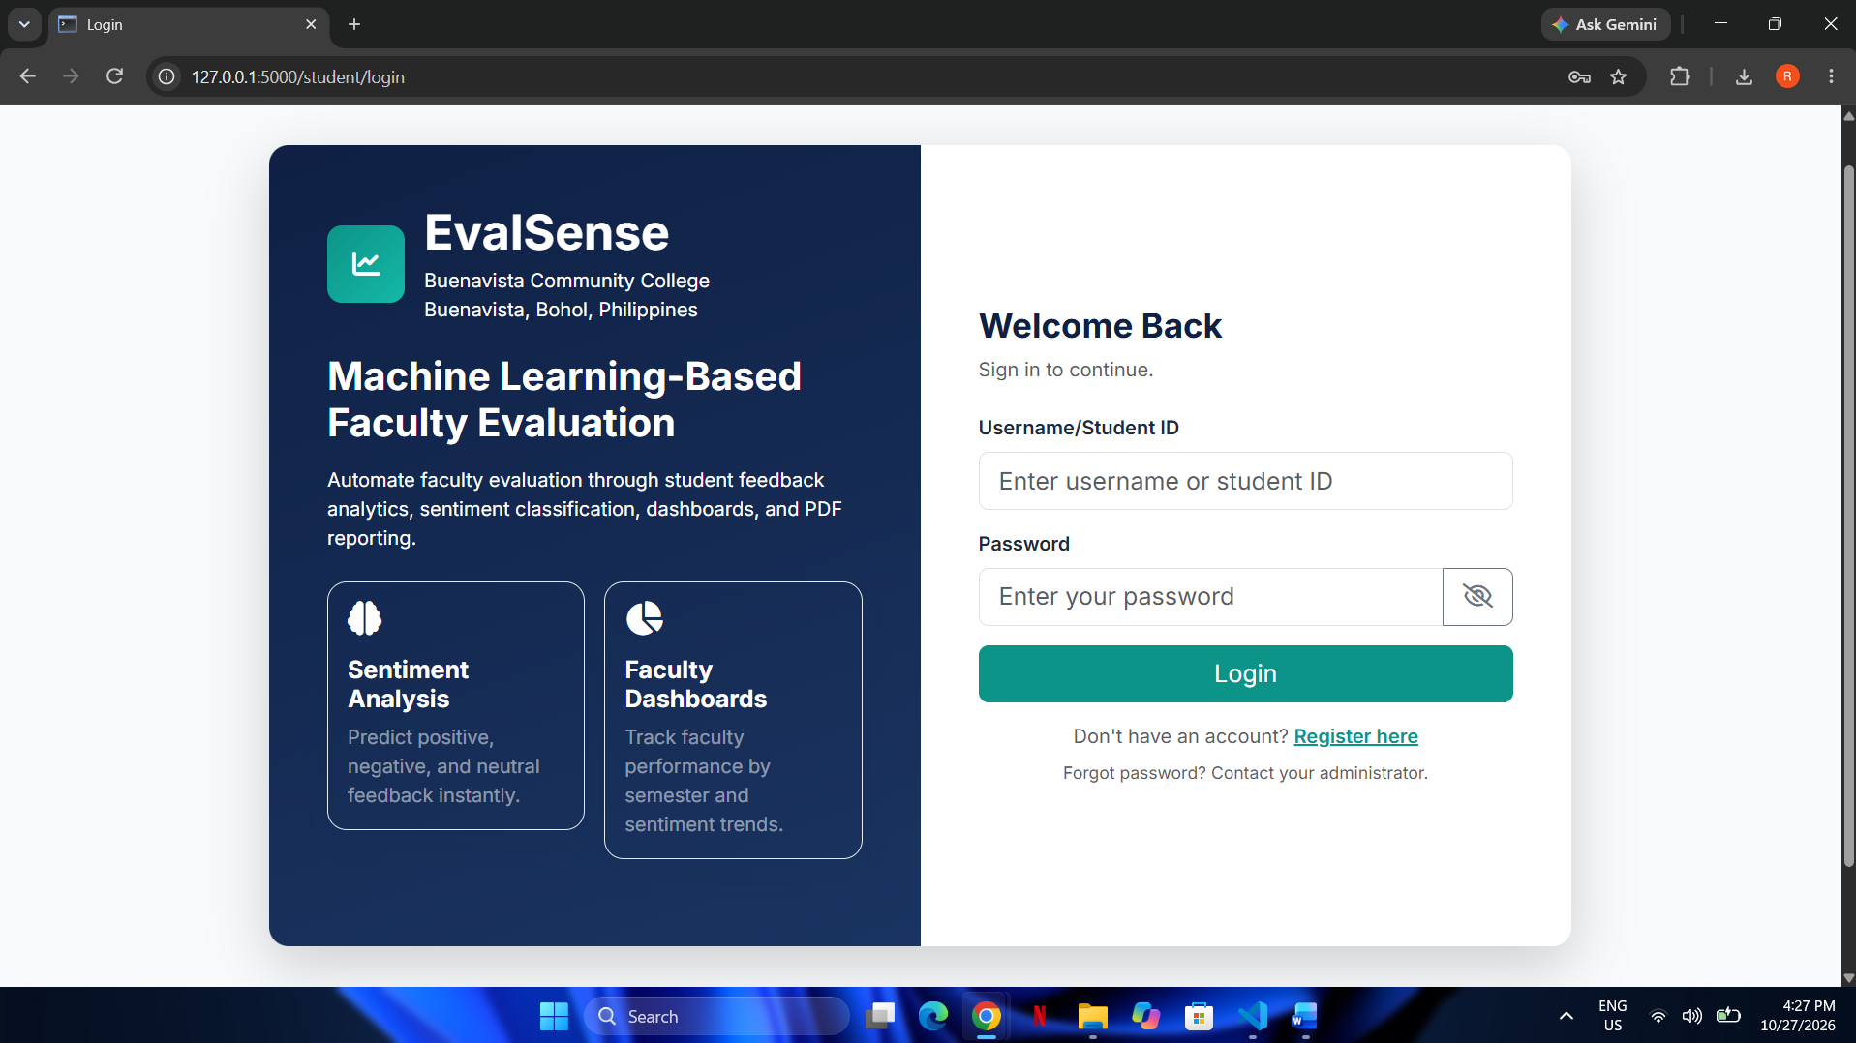
Open the EvalSense web address provided by the school or system administrator. Sign in with the username or student ID and password assigned to your account. Student accounts can also be registered from the login page where registration is enabled. Administrator accounts are created by the system administrator.
After signing in, use the navigation menu to open the pages available for your account role. Select Log out when finished, especially on a shared device.

E.2 Student tasks

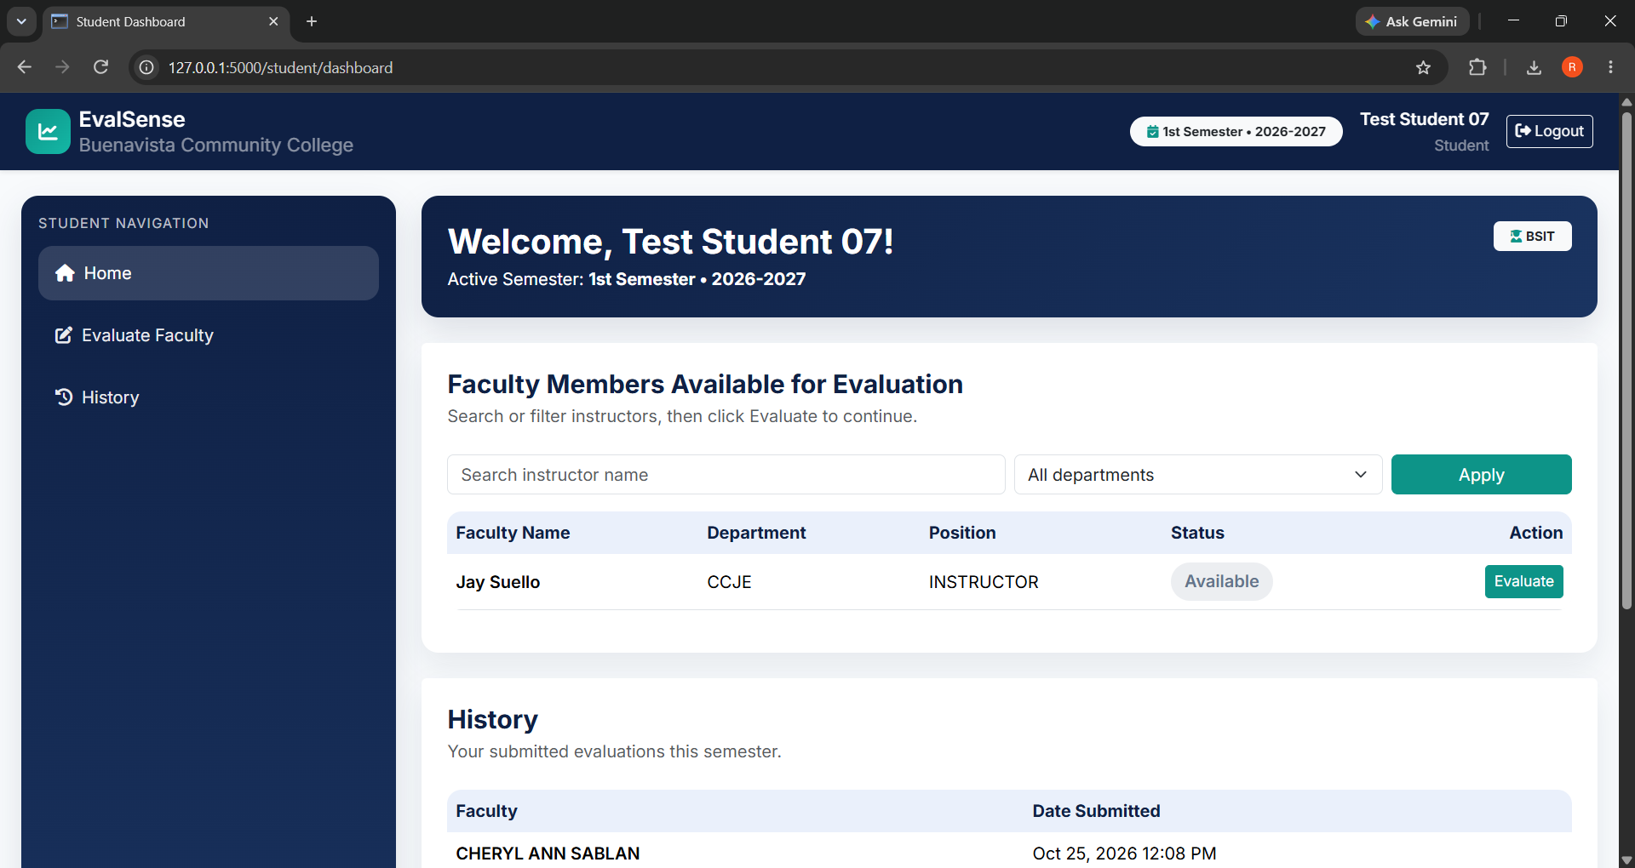
1. Open Home (Student Dashboard). Check the active semester shown near the top of the page. If no active semester is listed, evaluations are unavailable until an administrator activates one.
2. Find a faculty member using the name search or department filter. Select Evaluate beside the faculty member.
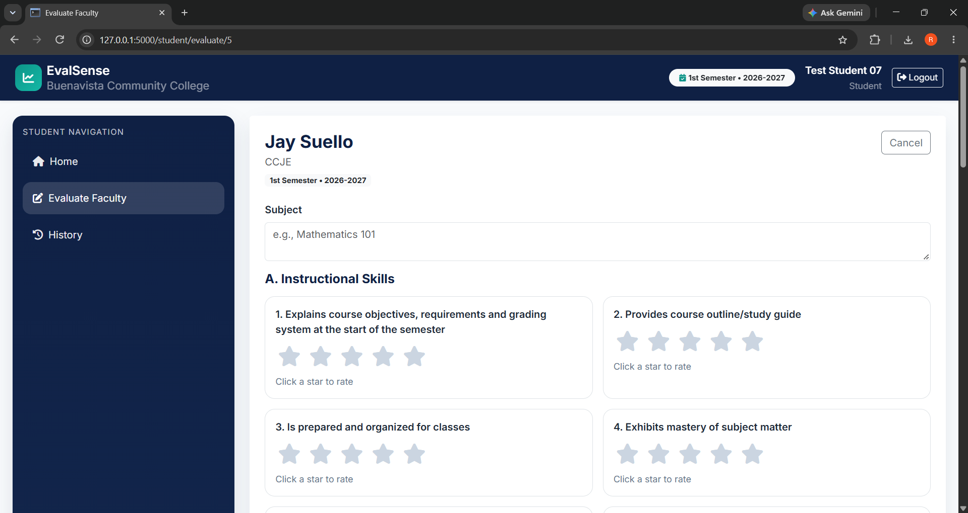
3. Complete the evaluation form. Choose a rating from 1 to 5 for each instructional and personal/social criterion. Enter the subject and written comment, then submit the form. The form requires all ratings and a comment of 10 to 2,000 characters.
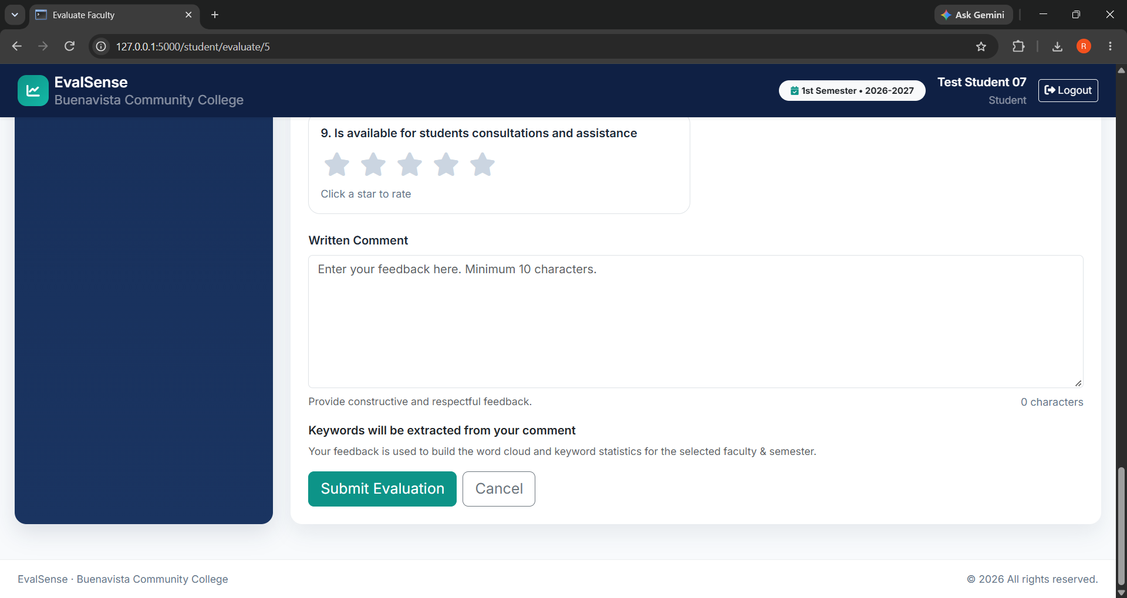
4. Review the confirmation page after submission. The system calculates an overall rating and analyzes the written comment for positive, negative, or neutral sentiment.
5. Return to Home and use History to view your submitted evaluations for the active semester.
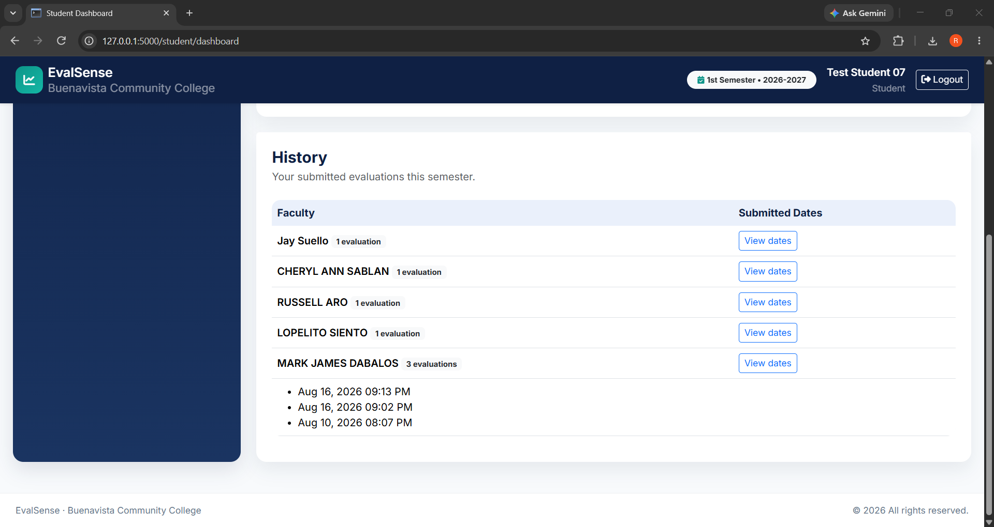
A student may submit up to three evaluations for the same faculty member in a semester. Contact the administrator if the faculty member or active semester is missing, or if your account needs assistance.

E.3 Administrator tasks
Sign in through the administrator login page with the administrator account created during setup. The administrator navigation provides Dashboard, Evaluations & Faculty Reports, Students, Sentiment Analysis, Keywords, and Faculty & Semester pages.
Manage students
Open Students to create student accounts, review the account list, update account details, activate or deactivate accounts, or reset a student password. Give reset credentials to the student through the school’s approved process.
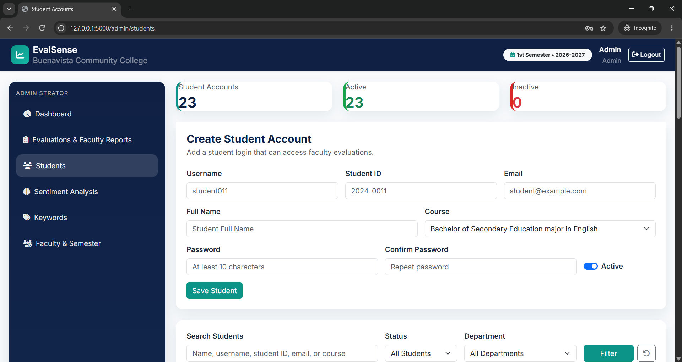

Manage faculty and semesters
Open Faculty & Semester to add faculty members and maintain their names, departments, positions, and active status. Use the semester form to enter a label, school year, start date, and end date. Mark the semester that should currently accept evaluations as active.
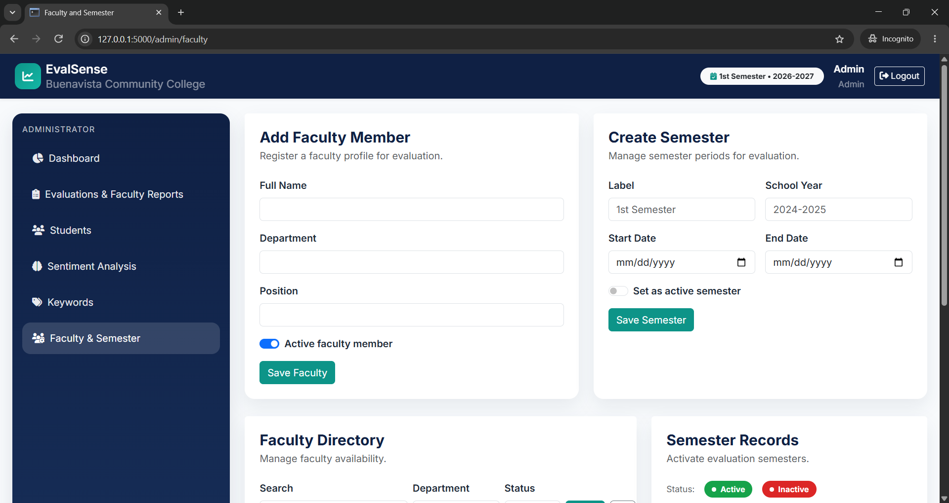

Review evaluation insights
Use Dashboard for summarized performance information. Open Sentiment Analysis to review sentiment results and Keywords to review common terms extracted from student comments. Use the semester selector where available to view the intended reporting period.
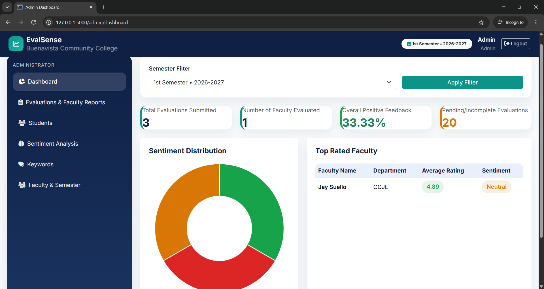

Generate reports
Open Evaluations & Faculty Reports, select the semester, and review faculty evaluation summaries. Use the individual faculty download action to export a PDF for one faculty member, or Download All Reports to export the available faculty reports.
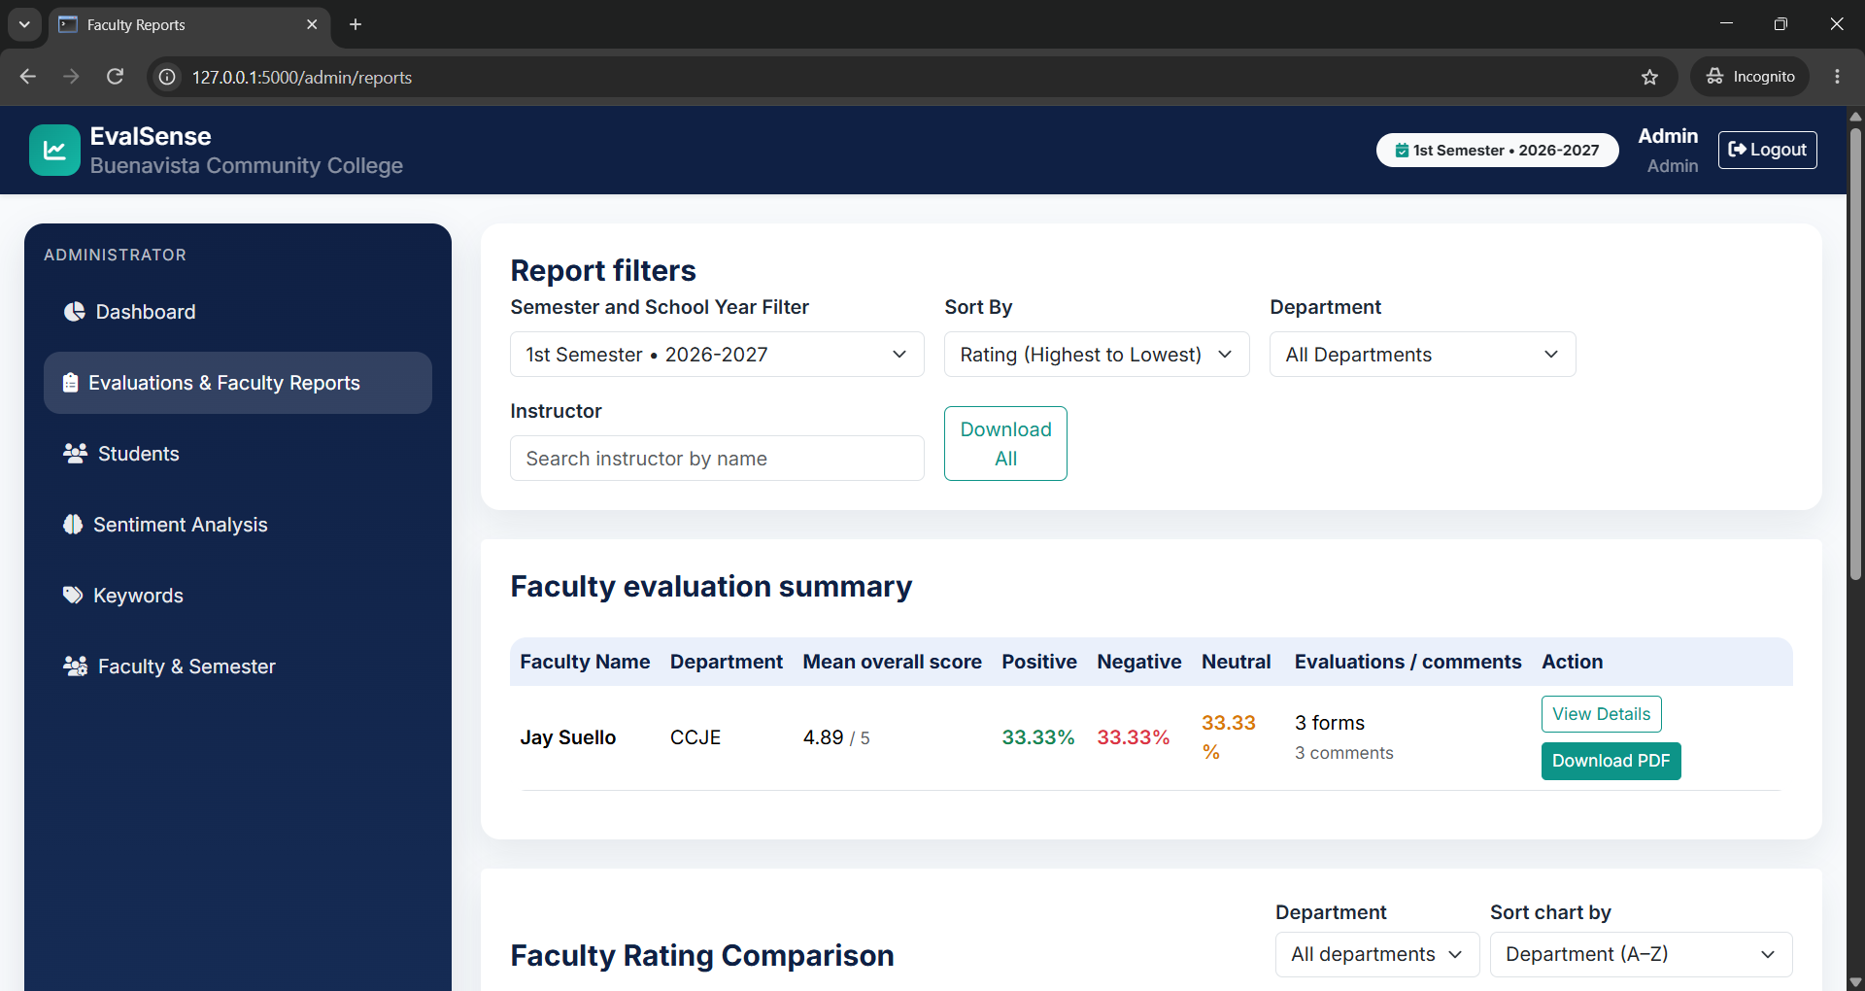

E.4 Responsible use
Submit one thoughtful and respectful evaluation based on your experience. Avoid including names or other personal information in written comments. Administrators should protect account credentials, restrict access to authorized personnel, and handle evaluation data according to school policy.

E.5 If you need help
For login problems, a missing faculty member, an unavailable semester, or questions about evaluation records, contact the EvalSense administrator at Buenavista Community College.

